We’re going on a BUG hunt.
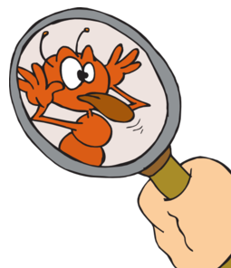
We’re going to catch

a BIG one!
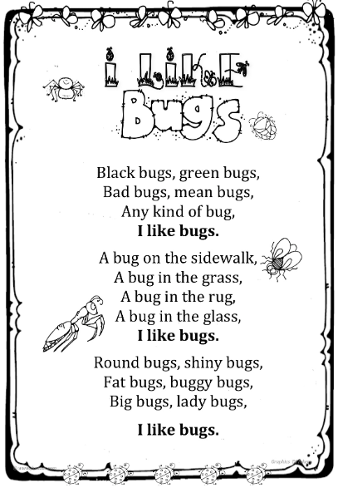
Here is this week’s challenge: let’s go on a hunt! Not for bears, but for BUGS! You’ll find them wherever you are – in your house, in the garden, in the park, even in school! With or without a magnifying glass, you’ll see them, if you look closely.
So, find as many bugs as you can. Draw each one on a separate piece of paper, e.g. post-it-note. Try to include as many details as you can. Can you label the bugs? If you’re not sure about a bug’s name, ask an adult or download the free Picture Insect App to help you. Once you have found all bugs you can, sort them in different ways and take pictures. Here are some examples of how you can do this:
- According to their size – big or small
- Number of legs – six, eight, no legs
- Wings or no wings
- Colours and patterns
- How do they move – crawl, hop, fly, fast, slow?
- Can you think of your own criteria?
Choose your favourite bug and create a fact sheet about it. Can you include some interesting or curious information? We’d love to see your amazing word so send us your pictures and fact sheets on homelearning@curwen.ttlt.academy.

