Fun Family Science
Activities

Supersize marshmallow
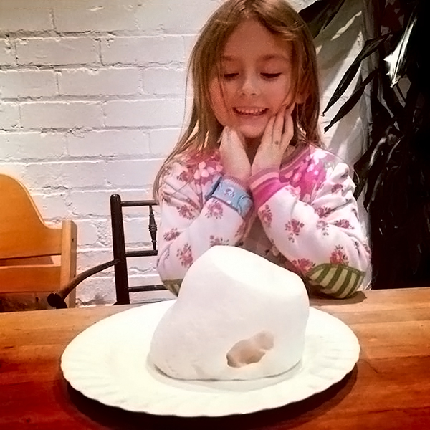
1. Put a large marshmallow on a plate and ask a grown-up to microwave it for 30-60 seconds.
2. You’ll see that it grows...and grows... and what do you think happens inside the marshmallow?

Prediction | Findings

Milk art
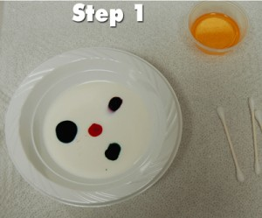
1. Pour the milk into the bowl. Be careful not to move the bowl, you want the milk as still as possible.
2. Put one drop of each color in different places in the milk.
3. Put just a tiny amount of soap on the end of the cotton swab, then touch it to one of the colors. WOW!
4. Let the experimenting begin!
5. To clean up, just pour the milk down the drain. (Do not drink it)

Prediction | Findings

Other factors to consider:
Does the temperature of the milk have any effect?
Try whole milk and skimmed milk.
Sprinkle pepper on the milk before you add the soap, what happens to the pepper?

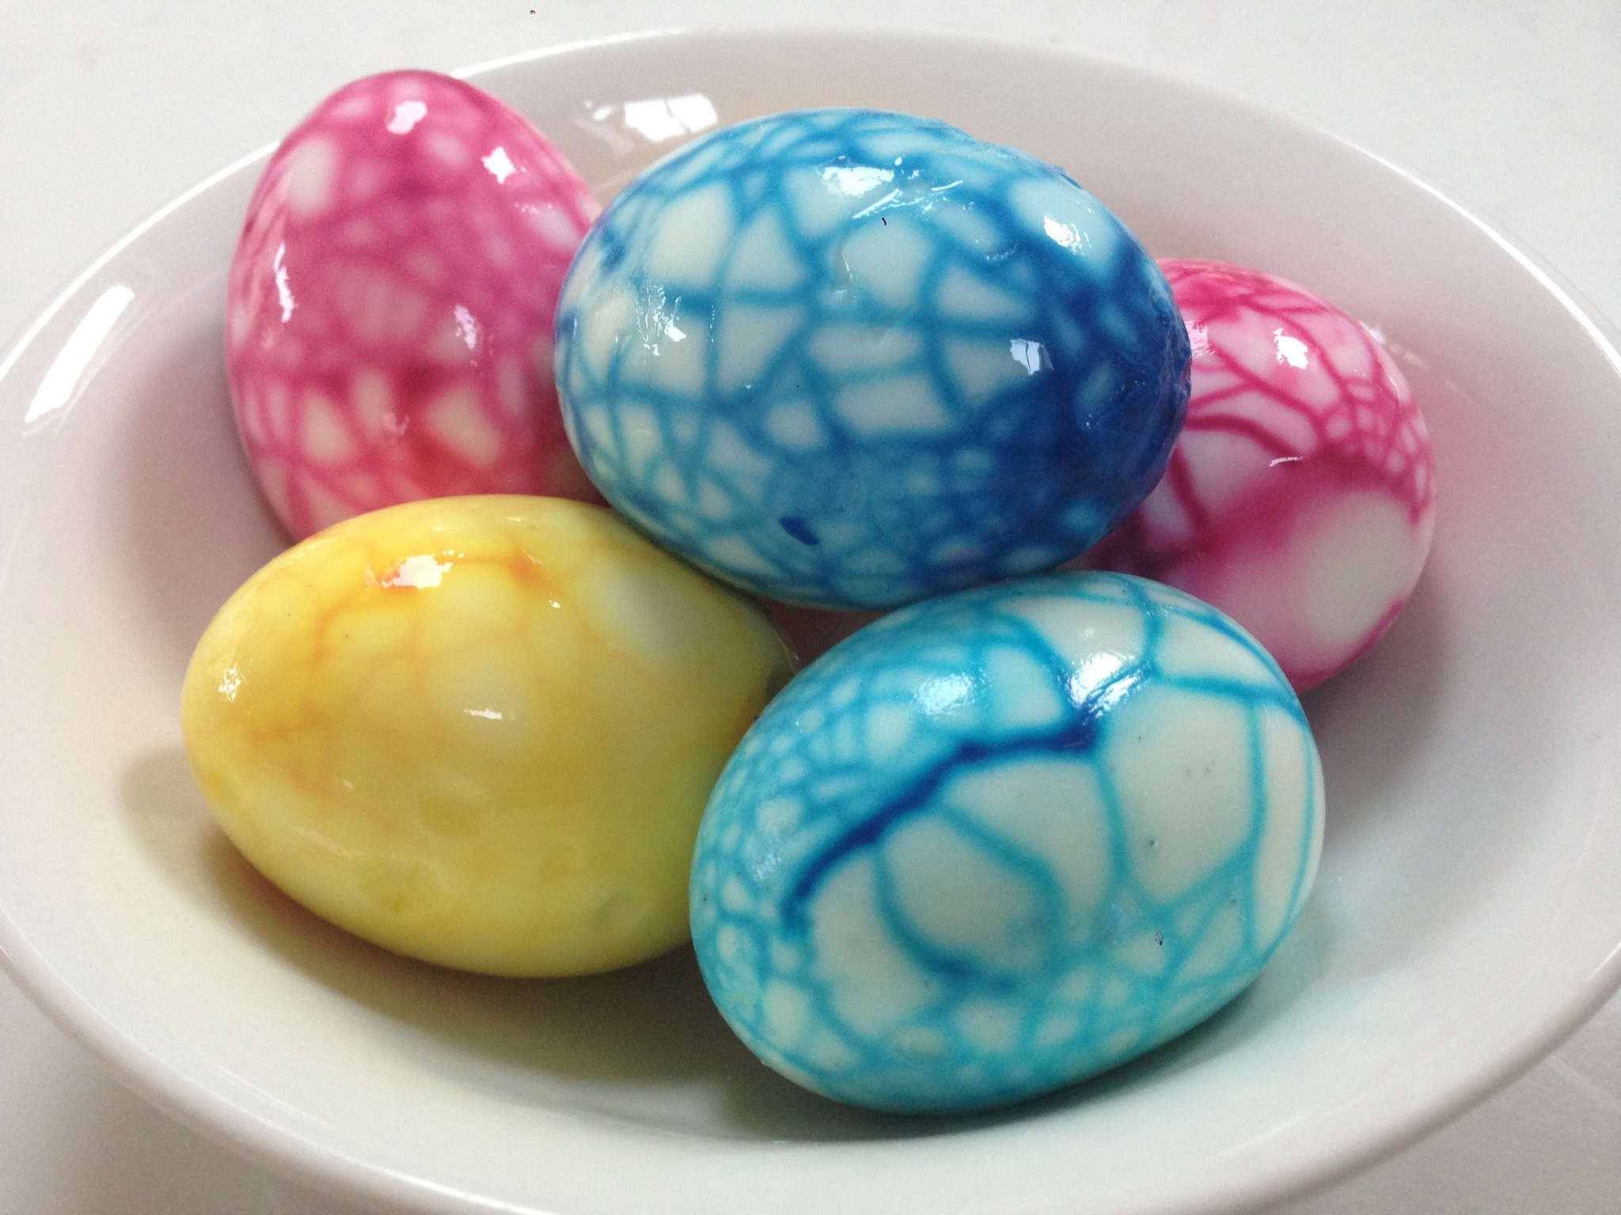
Dragon eggs
You will need: eggs and food colouring
Step-by-step guide to making dragon eggs:
1. Ask a grown-up to hard-boil some eggs.
2. Let them cool and then roll them on the work-surface to crackle the shell all over.
3. Half-fill some cups with water and mix in a good dollop of food colouring into each cup (the gel pastes work best).
4. Pop an egg into each cup and leave in the fridge overnight.
5. Peel off the shell and you’ll see that the dye is taken up wherever the shell is cracked.
6. Now gobble them up!

Paper hovercrafts
- 1. Start by folding the square in half corner to corner to make a triangle.

- 2. Fold that triangle in half corner to corner to form a smaller triangle

- 3. Unfold the previous fold to get the larger triangle. Fold the edges of the triangle into the newly-made crease to form a kite shape.

- 4. Fold the inside edges of the kite shape toward the outside edges as shown.

- 5. Turn the paper upside down and blow gently into the open end. Does your hovercraft zoom away!

Here is the link for further images to help.
https://www.sciencefun.org/kidszone/experiments/paper-hovercrafts/
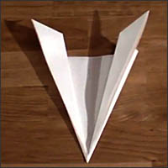

Prediction | Findings

Other factors to consider:
These little hovercrafts are so easy to make, it doesn’t take long to build some out of different materials (newspaper, cardboard, aluminum foil) or different sizes see which ones drive the straightest, go the fastest, or take the most breath to get moving!

- You will need:
- Glass canning jar
- Ceramic plate
- Hot water(parental guidance with this part)
- 4 ice cubes

- Pour two inches of the hot water into the canning jar.
- Cover the jar with the ceramic plate face up.
- Wait 3 minutes to continue to the next step.
- Put ice cubes on the plate.
- Observe your homemade water cycle.

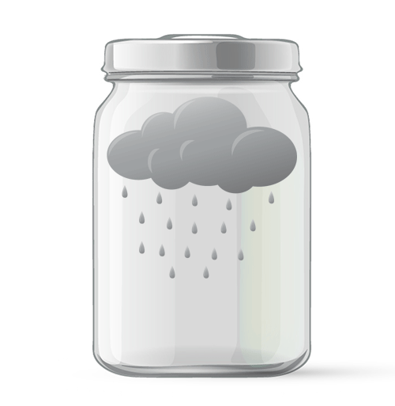
Make it rain

Prediction | Findings

Other factors to consider:
- Do two separate experiments at the same time. Have all the variables controlled except for the temperature of the water. Have one hot and one cold. How does it affect the experiment?
- Try using a paper plate instead of a ceramic plate. Which one worked better? Could the results have anything to do with absorption? Or not?
- Now think on a bigger scale, the world scale. Draw a picture of your experiment, but draw it to reflect what happens in the world’s water cycle.

