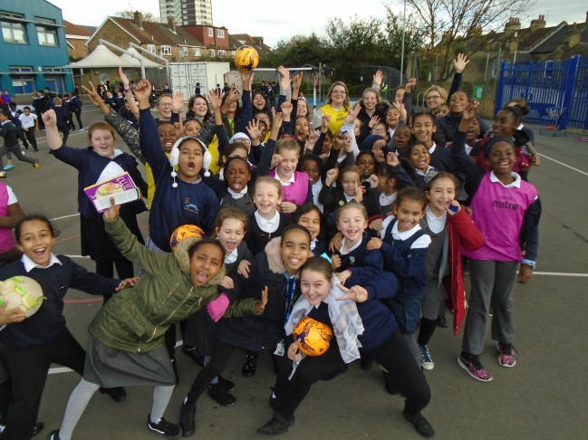
Girls Football Week 6-12th November 2017

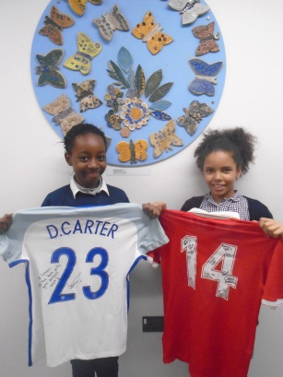

What a week!
Here at Curwen the girls were able to get involved with Girls football week. All week the girls were able to get involved in lots of different activities for Football and learn and understand more about the game and where it all started! Over 150 individual girls turned up and showed what they were made of!
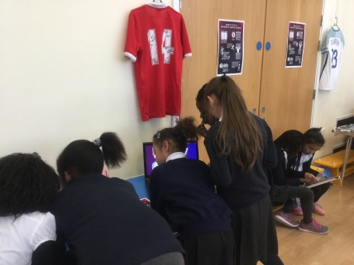
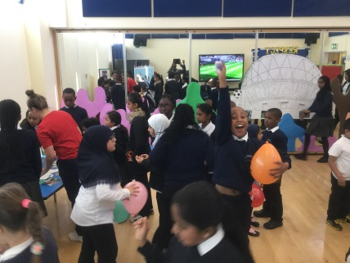
On Monday, the girls were able to attend a workshop with the delightful Dance Studio transformed into Wembley Stadium! Here they were able to learn about how girls football started, how many teams there are in the Women’s Super League, Premier League and the World Cup, and what female role models are out there right now playing women’s football. We also had our hall f fame with Leyton Orient Ladies and Danielle Carter, the Arsenal Ladies and England Ladies player, sign a shirt for the girls at Curwen. We would like to thank them personally for those shirts!
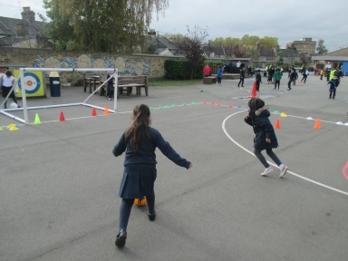
On Tuesday, Wednesday and Thursday, it was full of football outside on the football pitch! The girls from years 3-6 showed up and showed off their skills to prove to the boys that us girls can play football! Liepa showed of her amazing headers and Saima showing off her skills with the ball! Tamara took the ball around players whilst Alayna took on two defenders! Miss Montiel beat Miss Stuart in a kick up challenge but none the less Miss Stuart came back fighting as usual!
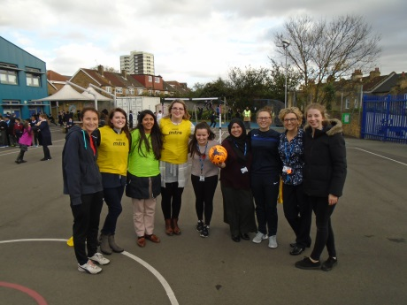
Then Friday approached us and The Big Game begun! So many girls turned up and played and scored some fantastic goals. It was great to see the staff get involved. On one team we had Miss Tully, Miss Montiel, Miss Cottis, Miss White and Miss Crosland, the other team, Mrs Khan, Mrs Sandhu, Miss Stuart, Mrs Patel and Miss Baratinsky. It was a gruelling match with Miss Cottis nearly scoring but Mrs Sandu made a mighty save!
It was fantastic to see so many new girls come and join in with Girls Football Week and enjoy a game of football. Well done to every girl that participated!
The PE Team

