Sink or Float Experiment

You will need:
- Deep bowl or bucket filled with water
- 6 – 8 medium sized objects for example fruits, spoon, sponge, ball, toy or empty bottle

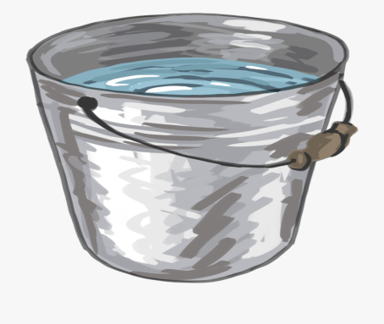
Method:
- Fill up a bowl or bucket with water

- Before placing an object into the water, predict if you think it will sink or float. Remember to place one object at a time.

- As you place the objects into the water, watch very carefully to see whether they will sink or float. Use the table below to record your findings
Object | Sink | Float
Example: Rubber duck |  | X

